Problem Statement: Automated GST Bifurcation for Multi-State Amazon Orders
Date: November 07, 2025

1. Background / Context
We Sumeet Cookware have GST registrations in 15+ states. Orders are fulfilled from multiple Amazon warehouses. For compliance, GST liability depends on the origin warehouse state vs. destination customer state.
- If order source state == customer delivery state → CGST + SGST applies
- If order source state ≠ customer delivery state → IGST applies
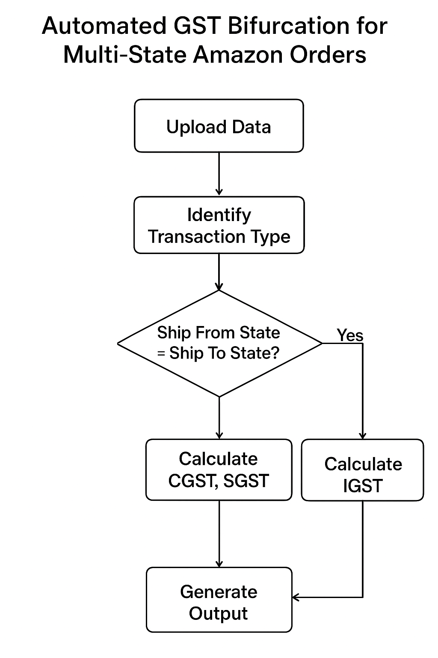
Currently, we manually download Amazon Sales Reports and apply multiple filters in Excel to calculate GST bifurcation. This is extremely time-consuming and error-prone, especially for clients who have 10–15 state registrations.

2. Current Operational Issue
- Amazon sales reports contain mixed data for all states.
- Manually filtering warehouse GST numbers & destination states takes significant time.
- For 15+ states, the combinations become very large and complex to manage manually.
- The compliance team wastes hours on filtering for SGST/CGST/IGST mapping instead of focusing on analysis.

3. Objective
To build a software tool that automatically reads bulk Amazon Sales Reports and provides a final GST summary state-wise without requiring manual filtering.

4. Expected Output
The software must generate an automated summary table as follows:
Origin State | Destination State | Tax Type (CGST+SGST / IGST) | Taxable Amount | GST Amount
[State A] | [State A] | CGST + SGST | ₹0.00 | ₹0.00
[State A] | [State B] | IGST | ₹0.00 | ₹0.00
Additionally, the system must:
- Identify the correct tax type automatically based on the logic defined in Section 1.
- Provide a final summary by state (Total SGST/CGST vs. Total IGST).
- Export results in Excel (.xlsx) or CSV format.

5. Input Source
- Source File: Amazon “All Order Sales Report” (from Seller Central).
- Ingestion Method: Manual upload (primary) OR fetch via API (secondary/future).
Key Data Points in Report:
- Seller GST No.
- Warehouse State
- Buyer State
- Tax Amount

6. Required Workflow
- Upload: User uploads the Amazon Sales Report (.csv).
- Identify Origin: System reads the origin warehouse state based on the GST number in the row.
- Identify Destination: System checks the destination customer state.
- Categorize: System automatically categorizes each order line into either CGST+SGST or IGST.
- Generate: System produces the summary table on-screen and offers a detailed Excel export.

7. Outcome
This tool will eliminate manual filtering, significantly reduce compliance time and human errors, and allow for easy scaling even as the number of registered states increases (e.g., to 15+ states).

8. Future Scope (Optional)
- Integration with Tally for automated voucher entry.
- Direct API fetch from Amazon to eliminate manual report downloading.
- Auto GSTR-1 mapping capabilities.

